**Uncertainty analysis or Sensitivity analysis**

One definition of sensitivity analysis is as follows,

“*The study of how uncertainty in the output of a model (numerical or otherwise) can be apportioned to different sources of uncertainty in the model input.*” (Saltelli *et al.*, 2004).

Aim: To attribute the uncertainty in the overall response variable, e.g. CUE estimate, to different parameters. The result may provide critical direction in efforts to reduce uncertainty by focusing data collection and synthesis on the specific parameter.

Uncertainty information is often obtained using Monte Carlo technique. The Variance-based sensitivity analysis, Sobol indices (Cariboni et al. 2007, Saltelli et al. 2008), has been a suitable option to partition the Monte Carlo uncertainty.

Given a mathematical or computational model

$$Y=f(X_{1},X_{2}⋯X_{k})$$

where the input factors $X_{1}$’s are uncorrelated with one another, one can see $Y$ as the realization of a stochastic process obtained by sampling each of the $X_{i}$ from its marginal distribution. The sensitivity indices are related to the decomposition of the variance of $Y$ into terms either due to each $X_{i}$ taken singularly (first order indices), as well as into terms due to the cooperative effects of more than one $X_{i}$.

The univariate effect of specific parameter *Xi* (i.e. first-order index) can be calculated as

$$S_{i}=\frac{Var\left[E\left[Y\left|X_{i}\right.\right]\right]}{Var\left[E\left[Y\right]\right]}$$

Meanwhile, the total effect of specific parameter accounting for all interactions with others (i.e. total-effect index) is

$$S_{Ti}=1-\frac{Var\left[E\left[Y\left|X_{\sim i}\right.\right]\right]}{Var\left[E\left[Y\right]\right]}$$

Where $X_{\sim i}$ refers to all parameters except ${ X}_{i}$.

The first-order index $S_{i}$ excludes the interaction effect among parameters, while the interaction effect between $X_{i}$ and $X_{j}$  is counted in both $S_{Ti}$  *and $S_{Tj}$* . Thus, the sum of the $S_{i}$ or $S_{Ti}$  will only be equal to 1 when the model is purely [additive](https://en.wikipedia.org/wiki/Additive_map).

$$\sum_{n=}^{k}{S_{i}}≤1$$

$$\sum_{i=1}^{k}{S_{Ti}}≥1$$

**How to calculate**

The most straightforward approach for calculating the part $Var\left[E\left[Y\left|X_{j}\right.\right]\right]$ in $S_{j}=\frac{Var\left[E\left[Y\left|X_{j}\right.\right]\right]}{Var\left[E\left[Y\right]\right]}$ would be list all possible cases

$$\left[\begin{aligned}&x_{11} x_{12}⋅⋅⋅x_{1j}⋅⋅⋅x_{1k} \\ &x_{21} x_{22}⋅⋅⋅x_{1j}⋅⋅⋅x_{2k} \\ &⋅⋅⋅ ⋅⋅⋅ ⋅⋅⋅ ⋅⋅⋅ \\ &x_{n1} x_{n2}⋅⋅⋅x_{1j}⋅⋅⋅x_{nk}\end{aligned}\right],\left[\begin{aligned}&x_{11} x_{12}⋅⋅⋅x_{2j}⋅⋅⋅x_{1k} \\ &x_{21} x_{22}⋅⋅⋅x_{2j}⋅⋅⋅x_{2k} \\ &⋅⋅⋅ ⋅⋅⋅ ⋅⋅⋅ ⋅⋅⋅ \\ &x_{n1} x_{n2}⋅⋅⋅x_{2j}⋅⋅⋅x_{nk}\end{aligned}\right],⋯,\left[\begin{aligned}&x_{11} x_{12}⋅⋅⋅x_{nj}⋅⋅⋅x_{1k} \\ &x_{21} x_{22}⋅⋅⋅x_{nj}⋅⋅⋅x_{2k} \\ &⋅⋅⋅ ⋅⋅⋅ ⋅⋅⋅ ⋅⋅⋅ \\ &x_{n1} x_{n2}⋅⋅⋅x_{nj}⋅⋅⋅x_{nk}\end{aligned}\right]$$

where n is the sample size used for the Monte Carlo estimate.

Number of model runs will be about $n×n×k$. In fact, nobody is applying this approach because of the high computional cost.

**Saltelli’s approach**

A. Saltelli, 2002, *Making best use of model evaluations to compute sensitivity indices*, Computer Physics Communication, 145:580-297.

Two input sample matrices A and B are generated:

$$A=\left[\begin{aligned}&x_{11} x_{12}⋅⋅⋅x_{1j}⋅⋅⋅x_{1k} \\ &x_{21} x_{22}⋅⋅⋅x_{2j}⋅⋅⋅x_{2k} \\ &⋅⋅⋅ ⋅⋅⋅ ⋅⋅⋅ ⋅⋅⋅ \\ &x_{n1} x_{n2}⋅⋅⋅x_{nj}⋅⋅⋅x_{nk}\end{aligned}\right]$$

$$B=\left[\begin{aligned}&x_{11}^{'} x_{12}^{'}⋅⋅⋅x_{1j}^{'}⋅⋅⋅x_{1k}^{'} \\ &x_{21}^{'} x_{22}^{'}⋅⋅⋅x_{2j}^{'}⋅⋅⋅x_{2k}^{'} \\ &⋅⋅⋅ ⋅⋅⋅ ⋅⋅⋅ ⋅⋅⋅ \\ &x_{n1}^{'} x_{n2}^{'}⋅⋅⋅x_{nj}^{'}⋅⋅⋅x_{nk}^{'}\end{aligned}\right]$$

New matric $C_{j}$ can be generated generated from A and B as:

$C_{j}=\left[\begin{aligned}&x_{11}^{'} x_{12}^{'}⋅⋅⋅x_{1j}⋅⋅⋅x_{1k}^{'} \\ &x_{21}^{'} x_{22}^{'}⋅⋅⋅x_{2j}⋅⋅⋅x_{2k}^{'} \\ &⋅⋅⋅ ⋅⋅⋅ ⋅⋅⋅ ⋅⋅⋅ \\ &x_{n1}^{'} x_{n2}^{'}⋅⋅⋅x_{nj}⋅⋅⋅x_{nk}^{'}\end{aligned}\right]$

$$S_{j}=\frac{Var\left[E\left[Y\left|X_{j}\right.\right]\right]}{Var\left[E\left[Y\right]\right]}=\frac{(U_{j}-E^{2}\left[Y\right])}{Var\left[Y\right]}$$

$U_{j}$ can be obtained from values of y computed on matrices A and Cj, ie. by:

$${\hat{U}}_{j}=\frac{1}{n-1}\sum_{r=1}^{n}{f\left(x_{r1},x_{r2},⋯,x_{rj},⋯,x_{rk}\right)f(x_{r1}^{'}, x_{r2}^{'},⋯x_{r\left(j-1\right)}^{'}, x_{rj},x_{r(j+1)}^{'},⋯x_{rk}^{'})}$$

Number of model runs for the full set of first order sensitivity indices ${ S}_{i}$ will be about $n×(k+1)$.

**Example with R script**

The model is $$CUE=\frac{1}{1+c}\left[1-\frac{r_{f}+\frac{{r_{r}+ρ}_{M}(((c_{R}-c)s_{r}+c(s_{R}-s_{r}))+(1+c_{H}) h_{M}s_{H}+r_{R}+h_{M}r_{H}+ξ)}{1+ρ_{M}}\left(\frac{W_{RT}}{W_{f}}\right)+r_{w}\left(\frac{W_{w}}{W_{f}}\right)}{σ_{C}}\right]$$

There are 17 parameters for calculating the variable CUE. The purpose of the r scripts is to attribute the uncertainty in the overall response variable, i.e. CUE estimate, to different parameters.

Ranges of each parameters can be found in file ‘CUEprior.csv’.

Uncertainty information can be obtained using Monte Carlo technique.

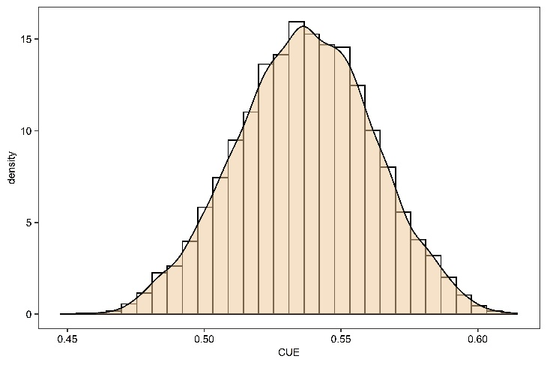

Fig.1 The density distribution of CUE calculated from the priori ranges of parameters

The function sobolSalt from package ’sensitivity’ implements the Monte Carlo estimation of the Sobol' indices for both first-order and total effect indices at the same time.

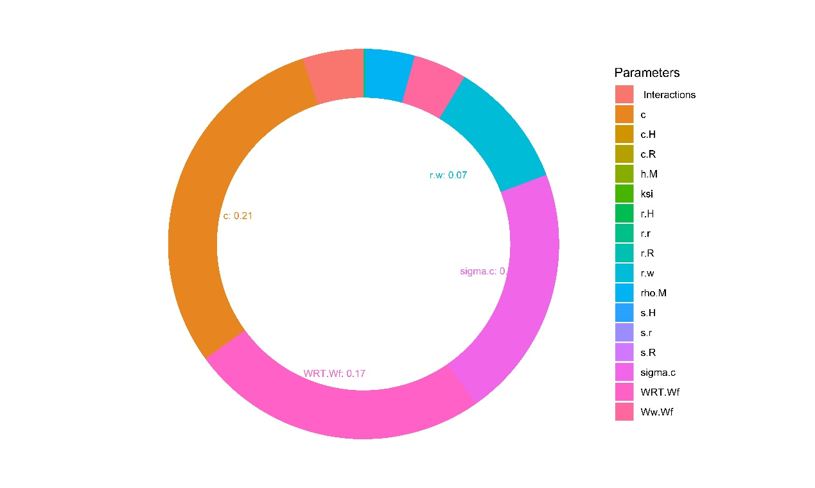

Fig.2 The contribution of different parameters to the variation of CUE (Sobol’s first order effect).